MCCP053 – Enduring Rollover Solution
Appendix 1
Detailed User Requirements for Enduring Rollover Solution

Summary
The core of the CMA’s requirement is for the introduction of a new module into the existing meter reading process which allows for rollover detection and flagging. The algorithms used in the new rollover detection module will either be those currently used, or a minor modification thereof. The flagging will return error messages to users where there is ambiguity or error in the rollover. Additionally, there will be changes to meter advance calculations to use a newly stored meter rollover flag.
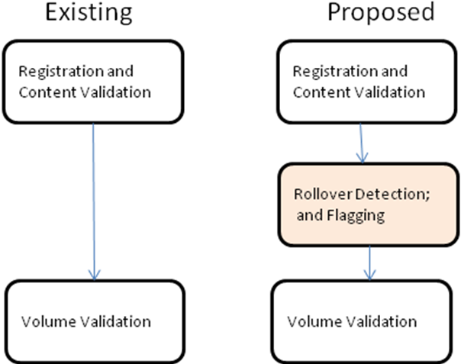

Background

At the Technical Panel meeting of 19 August 2010 MCCP053 “Enduring Rollover Solution” was approved allowing for the progression of an enduring Central System (CS) Solution for meter rollover. However, the MCCP only specified the high level requirement. This document provides the CMA’s detailed requirements.

This document should be read as being supplementary to the current version of the MCCP, and provides additional information and detail compared to the MCCP. In one specific area, the detail provided in this document differs from the high level MCCP proposal accepted by the Technical Panel in August 2010. This specific detail is highlighted below.

Current Meter Read Submission Process
The current Meter Read Submission Process is described in CSD0203, and shown diagrammatically in Appendix 2. There are two key aspects to the current process:
- Registration and Content Validation; and
- Volume Validation.

The first step, the Registrations and Content Validation - CSD0203 Section 2.1, checks matters such as:
- The appropriate party is submitting the read;
- The read is being submitted for a valid SPID/Meter Id; and
- That a re-read properly matches the original read.

The second step, Volume Validation- CSD0203 Section 2.2, checks
- the volume advance is within the expected range.

In checking the volume advance, the calculation currently makes use of the current “99xx”, “00xx” algorithm (CSD0204 - Section 2.1.2). Subsequent volume calculations within the CS (e.g. for settlement) also make use of the same algorithm.

MCCP – Key Aspect of the Proposed Solution

MCCP notes that there are two new key components to the proposed solution:
- The development of an improved rollover detection algorithm; and
- System Development to remove the current manual workaround.
The Central Systems will then make use of a revised method for calculating volume advances both at the meter read submission stage, and any subsequent volume calculations within the system.

These MCCP key aspects are developed in two stages:
- An overview of all the required changes; and
- A detailed requirement in respect of each change.

The new components should, as far as possible, be kept distinct from existing software components, to promote modularity in the CS design and implementation.

There are some components of the validation where there is unavoidable crossover between the existing and the new components (for example, the validation that a re-read is properly a re-read), but the new components should be kept logically distinct as far as practicable.

Overview of the Required Changes

- A high level description of the existing process is given in the diagram “Existing Process” in Appendix 2.
- The CMA’s requirements are given at a high level in the diagram “Proposed Process” in Appendix 2.
- Changes will need to be made to the “all transaction” flows which carry meter reads by the inclusion of:
  - an optional “Rollover_Indicator” field for incoming meter read flows; and
  - a mandatory “Rollover_Flag” for outgoing meter read flows.
Both these fields will have the values of True or False. The inclusion of these new fields will also require changes to be made to the LVI interface and the schema.
- The CMA will also return successfully submitted meter reads to the submitter of the meter read in addition to sending them on to other Trading Parties. This will ensure that all Trading Parties and the CMA have a common view of how the Rollover Flag has been set
- Changes will need to be made to the CS database to include a rollover indicator in the table which stores ignored meter reads. The rollover indicator will either take the value of the incoming Rollover_Indicator, or be NULL where the Rollover Indicator is omitted.
- Changes will need to be made to the database to include a rollover indicator and a rollover flag in the meter readings table. The rollover indicator will either take the value of the incoming Rollover_Indicator, or be NULL where the Rollover_Indicator is omitted. Every meter reading stored in the database will also have a corresponding rollover flag with the value True or False. This internally stored rollover flag will correspond exactly to the mandatory Rollover_Flag included on outgoing meter read flows.
- A new block of code will be inserted into this process comprising three steps:
  - Revised Rollover Detection;
  - Comparison of the result of the Revised Rollover Detection with the optionally submitted Rollover_Indicator; and
  - Subsequent processing dependent upon the comparison.
- Some enhancements will be needed to the existing meter read validation, including the Re-read Validation.
- Changes will need to be made to existing code which calculates meter advances to use the new rollover flag instead of the existing “99xx”,”00xx” algorithm. This applies both for volume validation for incoming meter reads, and for any settlement calculations which require volume calculation.
- Changes will need to be made to the CMA’s LVI screens to facilitate editing of both the meter reads and the new rollover flag. It is proposed that a small addition should be made to the existing editing facilities to also allow for the (i) insertion, and (ii) deletion of meter reads.

Detail in respect of the above changes
Changes to Transaction Flows and associated LVI Changes
There will be new fields which will carry:
- The optional Rollover_Indicatoron all meter read flows incoming to the CMA (T005.0, T005.1, T017.0); and
- The mandatory Rollover_Flag on all meter flows outgoing from the CMA (T005.2, T005.3, T017.1, T030.0, T030.1).
On incoming flows to the CMA, the Rollover_Indicator will be optional, and as specified by the Trading Party. The LVI will need to be changed in respect of each of the incoming flows to allow the Rollover_Indicator to be optionally specified by the users when they create meter reads. The Rollover_Indicator, where submitted by the Trading Parties, will be a Boolean type with a value of True of False.
For outgoing meter flows from the CMA, the Rollover_Flag will be mandatory and match the (meter read, rollover flag) pair which the CMA has stored in the meter reads table in the CS database. The Rollover_Flag will be set as either True of False. The setting will depend on whether or not the CMA has identified the meter read as being a rollover based upon (i) the setting of the incoming Rollover_Indicator, and (ii) the Revised Rollover Detection Algorithm. Example cases are provided below.

Corresponding changes will also be required to:
- LVI screens used by the users to submit meter read flows; and
- the schema.

Changes to the Database
There will need to be a change to the IgnoredMeterReadings table to include a copy of the optionally submitted Rollover_Indicator. The rollover indicator stored in the database will also be Boolean, but may be NULL in the case where a Rollover_Indicator is not submitted.

There will need to be a change to the MeterReadings table to add the meter rollover flag alongside the existing meter reads. The meter rollover flag will be a Boolean, and will always be set in the MeterReadings table, as it reflects whether or not a meter reading is to be considered to be a rollover. A copy of the optionally submitted Rollover Indicator will also be stored in the MeterReadings table. The rollover indicator stored in the database will also be Boolean, but may be NULL in the case where a Rollover_Indicator is not submitted.

There will need to be a one off exercise to determine whether existing reads comprise a rollover under the existing “99xx”, “00xx” rules and to set the new meter rollover flag appropriately for all existing reads in the MeterReadings table. It is proposed that the rollover indicator be set to NULL on all existing meter readings in the IgnoredMeterReadings table.

Code Block: Revised Rollover Detection and Comparison with the incoming Rollover Flag
- Revised Rollover Detection
The Revised Rollover Detection (RRD) algorithm will replace the existing “99xx”,”00xx” algorithm. For new candidate meter reads, the RRD will return one of three values:
- Rollover
- Not a Rollover
- Indeterminate
At this stage the full details of the RRD have not yet been fully developed. The RRD development should be kept modular to allow for changes to be made to the RRD if necessary. However, the following are required:
- For a new candidate meter read R₂ the existing algorithm only considers:
  - the new candidate read R₂ ;
  - the most recent read in the database R₁ (if it exists); and
  - the number of dial digits.
- The new algorithm may additionally make use of the meter read history, and in particular the second most recent read R₀ (if it exists).
At this point, only candidate algorithms can be provided, but would it is anticipated the RRD is likely to be similar to the following. There will be three parts to the RRD for a meter read submission:
- “Part 1: Rollover”;
- “Part 2: Not a Rollover”; and
- “Part 3: Indeterminate”.
Two candidate algorithms are provided below for “Part1: Rollover”, and one candidate algorithm for “Part 2: Not a Rollover”.” Part 3: Query” comprises all other cases.

“Part 1: Rollover”
Either
- Rollover – use the existing algorithm, ie
  - R₁ and R₂ of form “99xx” and “00xx” respectively (for four digit meters etc); or
- Rollover – use an extension of the existing algorithm.
All of the following conditions must be true:
  - R₁ and R₂ of form “9xxx” and “0xxx” respectively (for four digit meters etc); and
  - R₀ must exist; and
  - R₁ – R₀ < 20% of dial digit range, ie for a 4 digit meter R₁ – R₀ < 2000; and
  - Daily rate of advance between R₁ and R₂ satisfies the condition that it is greater than 20% of the daily rate of advance between R₀ and R₁ and less than 200% of the daily rate of advance between R₀ and R₁
Examples of these algorithms are provided at the end of this document.

Part 2: Not a Rollover
Not a Rollover: R₂ – R₁ > -1000. Ie the advance is either positive, or small negative (less than 1000 in magnitude). This test is the same test currently used by the CMA in its manual process. Meter reads which fail both this test and the “99xx”,”00xx” test are currently manually queried by the CMA as being “candidate rollovers”.

Part 3: Indeterminate
Indeterminate: Anything which does not fall into the “Rollover” or “Not Rollover” categories.

- Comparison of RRD result with incoming Rollover Flag
The comparison part of the new algorithm compares the results of the RRD with the optional Rollover_Indicator submitted with the incoming meter read. There are three possible results depending on whether or not the CS internal RRD produces compatible results with the submitted Rollover_Indicator:
- AGREE;
- DISAGREE; or
- QUERY.
There are two sub-results from “AGREE” (where the submitted Rollover_Indicator is compatible with the results of the RRD). These sub-results are:
- AGREE;
  - “Rollover Flag set TRUE”, or
  - “Rollover Flag set FALSE”.
In all cases where the result is either DISAGREE or QUERY, the incoming meter read flow will be rejected. Even in the case of a reread, the CMA will reject incoming meter read flows in the event of DISAGREE or QUERY. These cases are considered in more detail at the end of this paper.
Distinct error messages should be given to the two cases of DISAGREE and QUERY.

The table below shows the possible combinations.

 | Rollover_Indicator: True | Rollover_Indicator: False | Rollover_Indicator  Not set
RRD: Rollover | AGREE  Rollover Flag TRUE | DISAGREE | AGREE  Rollover Flag TRUE
RRD: Not Rollover | DISAGREE | AGREE  Rollover Flag FALSE | AGREE  Rollover Flag FALSE
RRD: Indeterminate | AGREE  Rollover Flag TRUE | AGREE  Rollover Flag FALSE | QUERY

Example
- An incoming flow has the Rollover_Indicator set as True and the RRD also identifies the read as a rollover. Provided the meter read passes the other existing validation test, the CMA will insert the meter read and the internal rollover flag as True into the CS, and notify users of the meter read, with the outgoing Rollover_Flag set to True;
- An incoming flow does not contain a Rollover Indicator, but the RRD detects a rollover. Provided that the meter read passes the other existing validation tests, then the CMA will insert the meter read and the internal rollover flag as True into the CS, and notify users of the meter read with the outgoing Rollover_Flag set to True.

- Subsequent Processing
The subsequent processing depends on the results of the table above, and is in accordance with the diagram labelled “Proposed Process”
- AGREE;
The meter read, together with the RolloverFlag as set in the table above, is passed on to volume validation.
- DISAGREE or QUERY
In both cases the read is rejected with a new error code to be specified.
For the avoidance of doubt, both DISAGREE and QUERY leads to “READ Rejected”. This is different to the “High Level Rollover Strawman” contained within the August version of the MCCP where DISAGREE and QUERY both led to a possible re-read.
Only in the case where the results of the RRD and the submitted flag are compatible, is the meter submission passed on for further processing.

Some enhancements to the existing Read Validation.
First we will need to validate that there is no Rollover_Indicator submitted alongside either an “I” or and “O” read. If not reject with a new Error Code.
Sections of code which compare new meter reads to previous meter reads (compare CSD 0203 Section 2.1.3 – Meter Read a duplicate for same Meter Read Date); and CSD0202 Section 2.2 Re-Reads, will both need to be enhanced.
For a read to be considered as an exact match and an OK message returned, then all of the Read Value, the Read Type, the Read Date and the Rollover Indicator of the current read must match the stored read.
Otherwise, if the Read Type is either “I” or “F” reject with same Error Code as at present.
Otherwise, if the Rollover_Indicators do not match, then reject with a new Error Code
Otherwise, if either the Read Type or the Read Value do not match then reject with the existing error code.
For a read to be accepted as a Re-read, all the incoming meter read fields must be identical to the previously submitted reads.
The code that stores submitted reads for use for use in read/re-read validation will need to be enhanced to include the submitted Rollover_Indicator

Meter Advance Calculation
All meter advance calculations will need to use the new rollover flag instead of the “99xx”, “00xx” algorithm.
For volume validation for incoming meter reads, the flag will be as determined from the table above (which combines the incoming submitted meter rollover indicator together with the RRD calculation in the CS).
For settlement calculations the rollover flag will be the rollover flag stored in the database, which is the outcome of that comparison exercise.

Additional LVI Changes
There will also need to be changes to the CMA’s LVI interface to facilitate editing of not only the meter reads, but also the associated meter rollover flag.
The meter editing function should be enhanced to allow the insertion and deletion of reads (including the rollover flag) as well as the editing of reads and the associated rollover flag.
The associated audits will need to be correspondingly enhanced.
Where a meter read is created by the CMA using the LVI, then the rollover indicator stored with the meter reading should be given the same value as the rollover flag. However, when a meter read is edited (date, reading or rollover flag), then the incoming rollover indicator should not be changed.

Discussion

Submission of Reads
It should be noted that with the proposed process, that it may now be necessary to submit a read/re-read on up to three occasions.

- A read is submitted without the rollover flag being stored. Then the read is rejected as a “Rollover QUERY”.
- The read should then be resubmitted with the Rollover_Flag appropriately set. It is possible that on this occasion the read fails volume validation (for example, the rate of advance is 250% times the previous rate of advance, and thus falls outside the 20% - 200% threshold).
- The read is resubmitted as a re-read, and this time passes the relaxed volume validation.
For example
Read History:
Date Meter Read Rollover_Indicator
2008-08-01 04KENT1234 9200 FALSE
2009-02-01 04KENT1234 9400 FALSE
2009-08-01 04KENT1234 9600 FALSE
The following read is submitted
2010-02-01 04KENT1234 0100 not set
The following will happen:
- Assuming that the existing algorithm “99xx”,”00xx” is used for rollover detection – the CS will not detect this read as RRD: Rollover. Nor will it detect it as RRD:Not Rollover. The CS will therefore identify this as RRD: Maybe. The combination of RRD:Indeterminate and the Rollover_Indicator not being set will result in QUERY and the read being rejected.
- The read is then resubmitted:
Date Meter Read Rollover_Indicator
2010-02-01 04KENT1234 0100 TRUE
- The CS will again detect the read as RRD:Indeterminate. Together with the Rollover _Indicator being set, this will result in the CS identifying “AGREE”, and setting the rollover flag which will be passed to the volume processing.
- At the volume processing, the advance will now be determined to be 500. This is 250% times the previous advance of 200, and outside the normal thresholds of 20% to 200%.
- The read is then resubmitted as a re-read.
Date Meter Read Rollover_Indicator Re-Read
2010-02-01 04KENT1234 0100 TRUE TRUE
- At this point the meter read is now accepted.

Alternatives were considered in which a ROLLOVER QUERY was stored, allowing for a subsequent meter read submission to contain both
- A properly set rollover flag; and
- The re-read flag.

This approach was rejected, as it leads to considerable difficulties if during the period of time between the initial read being submitted and the re-read being submitted, there is a Retrospective Amendment on the meter read history for that meter.

Meter Read DISAGREE
It has been noted above that in all cases where the results of the RRD strictly disagree with a submitted Rollover_Indicator, that the meter read is rejected. There are two possible cases:
RRD:Rollover and Rollover_Indicator=False
An example of this (using the current rollover algorithm would be if consecutive meter reads (for a four digit meter) of 9953 and 67 were submitted – but the Trading Party considered that this was not a meter rollover. The CS would accept the second read of 67 if a Retrospective Amendment were made to the read of 9953 to reduce the size of the negative advance, before the read of 67 were re-submitted.
RRD:Not Rollover and Rollover_Indicator=True
An example of this would be consecutive meter reads of 7120, 6340 which was deemed to be a rollover. Such reads could be accepted by the CS if a Retrospective Amendment were made to insert a read of (say) 1000 for which the Rollover Flag was set to be True.

Comparison of Rollover Detection Algorithms.
A full analysis of RRD algorithms has still to be conducted. Preliminary analysis has centred around extending the Rollover detection from “99xx”,”00xx” to something of the form “9xxx”,”0xxx” together with additional criterion such as volume advance.
This extension is considered with respect to a specific set of meter reads.

Consider the following set of meter reads for a four digit meter all at uniform 6 monthly intervals:
0700, 0800, 0900, 0999
Now consider what happens if a mistake is made in entering the third meter read. It is submitted as 9000 instead of 0900 – thus:
0700, 0800, 9000, 0999
Clearly, the read of 9000 will not be accepted by the CS on the first submission. It fails volume validation; but will be accepted by the CS on a re-read.
Now consider what happens with the 0999 read.
- With the existing “99xx”,”00xx” read this will not be identified as a rollover. Instead, it will be identified as RRD: Maybe. This allows the possibility of either correcting the 9000 back to 900, or accepting the 999 as a rollover.
- With the proposed “9xxx”,”0xxx” algorithm then the following would happen:
- 9000,0999 would pass the “9xxx”,”0xxx” test
- The advance of 1999 would pass the volume validation. The previous advance was 800 to 9000 ie 8200. The advance of 1999 thus falls within the 20% to 200% range.
- In this case the additional proposed test, that the previous advance (i.e. the 8200) must be below 20% of the range comes into play – and the 0999 read is identified as RRD:Indeterminate. Outcomes similar to the first algorithm are then possible
The CMA notes that real meter read examples similar to the above 0700,0800,9000,0999 have been submitted to the CS database. This is the reason that extensions to the current rollover algorithm are still being very carefully considered.
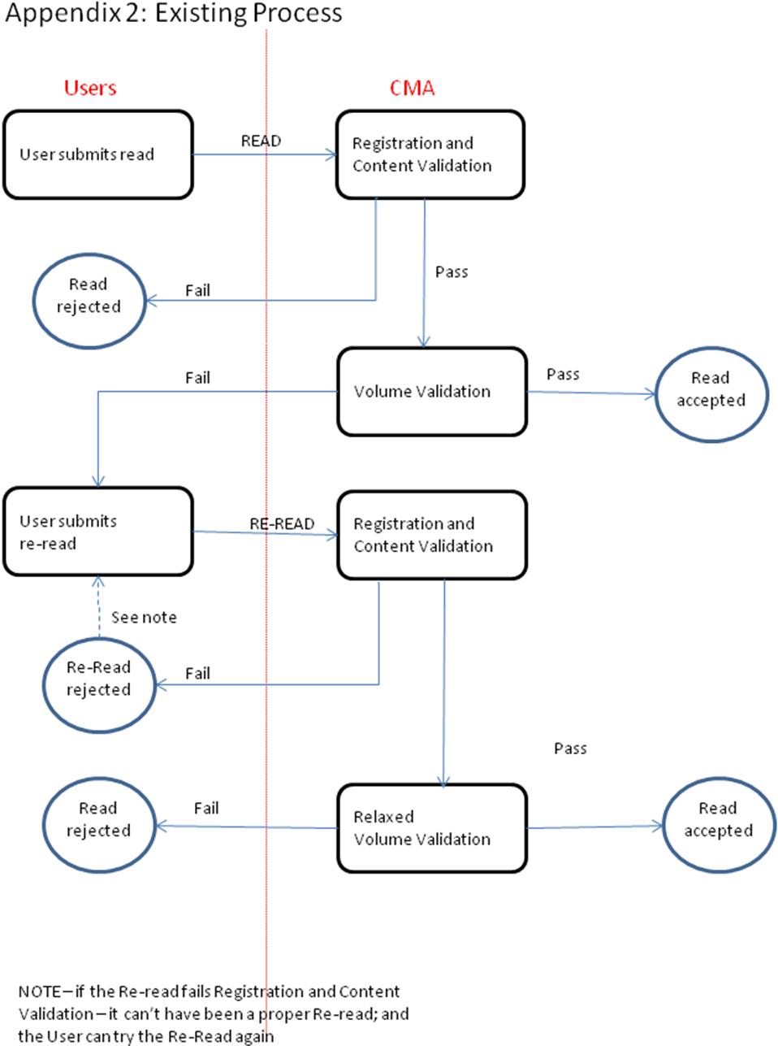
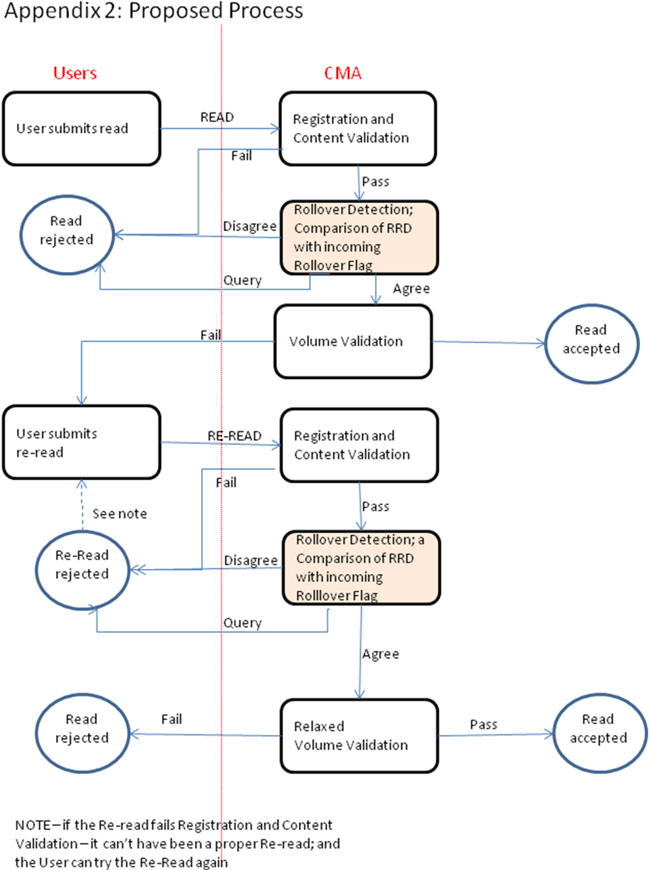

The appendices show the process for a re-read as being a continuation of the processes for that of a read. This is true in respect of the “lifecycle” of a read followed by a re-read. In practice, a re-read is handled by the same CS code as for a read (albeit that the pathways through the code can be slightly different). One such difference in the code pathways is the “relaxed volume validation” where currently only the physically possible/physically impossible test is applied to re-reads. Compare the CSD for details.
Strictly “99xx”,”00xx” refers to a 4 digit meter. For a 5 digit meter the reads to trigger a rollover are of the form “99xxx”,”00xxx”, and similarly for meters with more dial digits. The expression ‘“99xx”,”00xx” algorithm’ should be appropriately interpreted for different numbers of dial digits.
While the new Rollover_Indicator will be optional in respect of the incoming flows, there will be circumstances where the Rollover_Indicator must be set. In particular, where the CS is unable to unambiguously determine whether the meter read is a rollover or not. Where the CS is unable to unambiguously determine whether the meter read is a rollover or not, the Central System will reject the meter read flow if the Rollover_Indicator is not set. This rejection is carried out at the validation stage, rather than at the schema level.

